Q.1 Using console.log() print out the following statement: The quote 'There is no exercise better for the heart than reaching down and lifting people up.' by John Holmes teaches us to help one another. Using console.log() print out the following quote by Mother Teresa:

Ans : console.log(“'There is no exercise better for the heart than reaching down and lifting people up.' by John Holmes teaches us to help one another”)

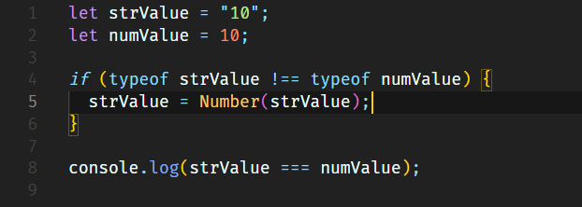Q.2 Check if typeof '10' is exactly equal to 10. If not make it exactly equal?

Ans:

Q.3 Write a JavaScript Program to find the area of a triangle?

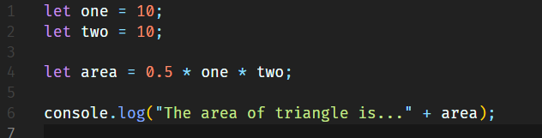Ans :

Q.5 What is Conditional Statements in JS ?

Ans : A condition statement (also called a conditional or control statement) in programming allows code to execute based on whether a specific condition is true or false. It helps control the flow of the program by making decisions based on the conditions evaluated at runtime.

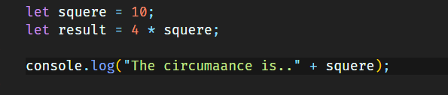Q.6 Find circumference of Rectangle formula : C = 4 * a ?

Ans :

Q.7 WAP to convert years into days and days into years?

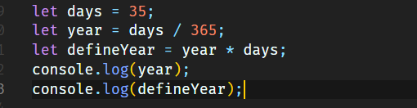Ans:

Q.8 Convert temperature Fahrenheit to Celsius? (Conditional logic Question)

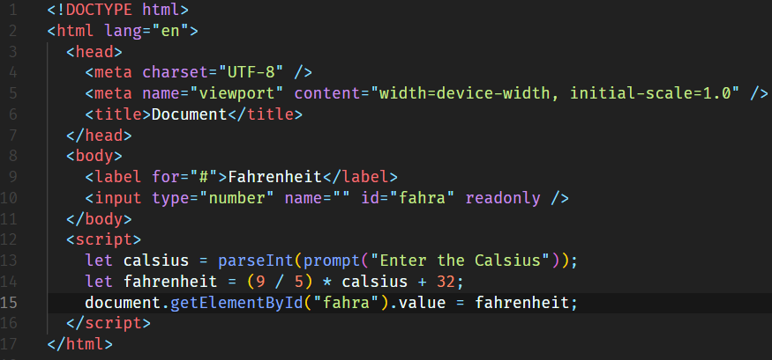Ans :

Q.9 Write a JavaScript exercise to get the extension of a filename.?

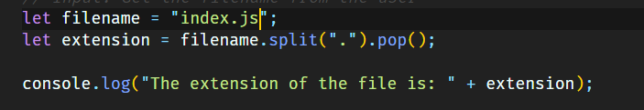Ans:

Q.10 What is the result of the expression (5 > 3 && 2 < 4)?

Ans : 5 > 3: This is true because 5 is greater than 3.

2 < 4: This is true because 2 is less than 4.

Q.11 What is the result of the expression (true && 1 && "hello")?

Ans : “hello”

Q.12 What is the result of the expression true && false || false && true?

Ans : False

Q.13 Check Number Is Positive or Negative in JavaScript?

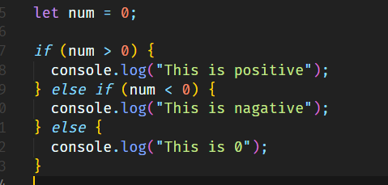Ans :

Q.14 Find the Character Is Vowel or Not ?

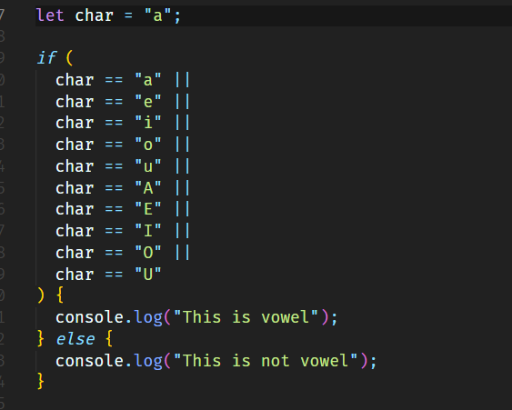Ans :

Q.15 Write to check whether a number is negative, positive or zero?

Ans :

Q.16 Write to find number is even or odd using ternary operator in JS?

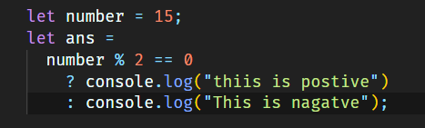Ans :

Q.17 Write find maximum number among 3 numbers using ternary operator in JS?

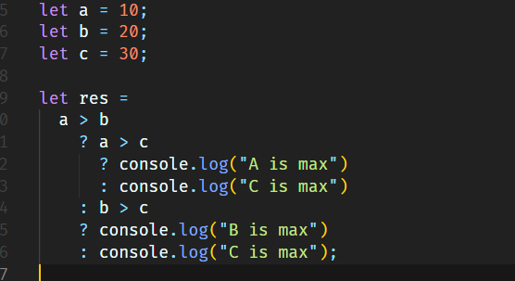Ans :

Q.18Write to find minimum number among 3 numbers using ternary operator in JS?

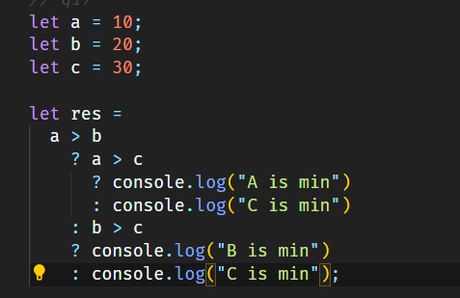Ans :

Q.19 Write to find the largest of three numbers in JS?

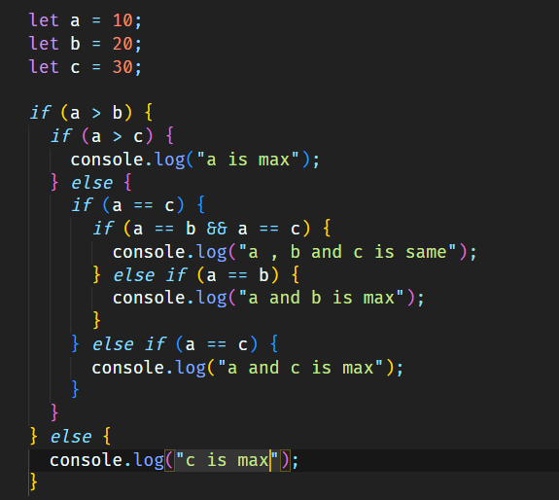Ans:

Q.20Write to show Monday to Sunday using switch case in JS? ii. Vowel or Consonant using switch case in JS ?

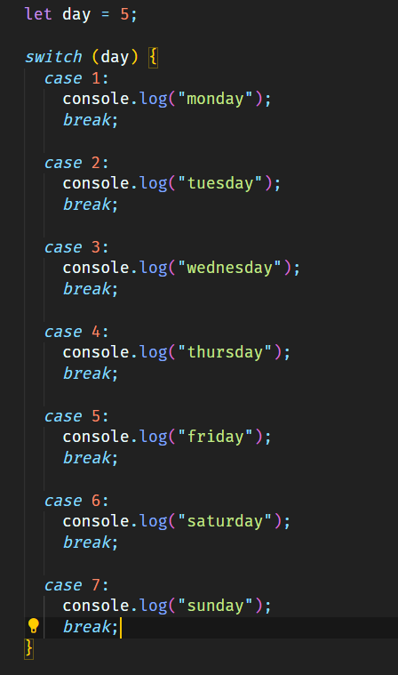Ans:

Q.21What are the looping structures in JavaScript? Any one Example?

Ans : Loops in JavaScript execute a block of code again and again while the condition is true example.

for (let i = 0; i < 5; i++) {

console.log("Hello World!");

}

Q.22Write a print 972 to 897 using for loop in JS?

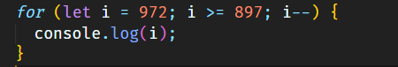Ans :

Q.23Write to print factorial of given number?

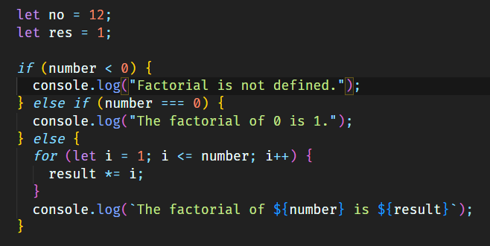Ans:

Q.24Write to print Fibonacci series up to given numbers?

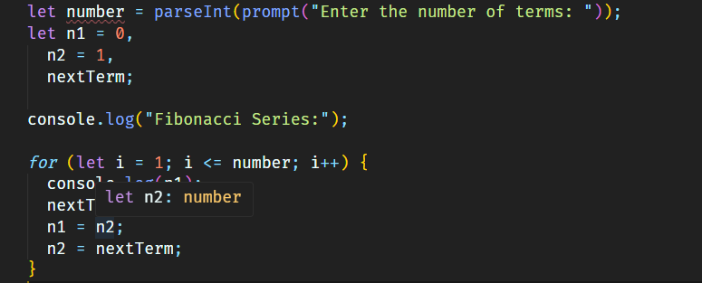Ans:

Q.25Write to print number in reverse order e.g.: number = 64728 ---> reverse =82746 in JS?

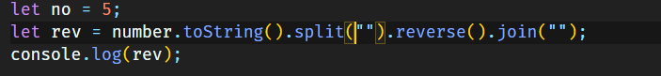Ans :

Q.26Write a program make a summation of given number (E.g., 1523 Ans: - 11) in JS?

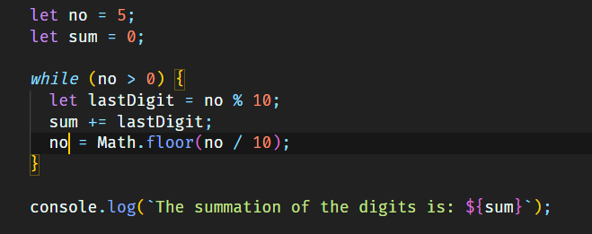Ans:

Q.27 Write a program you have to make a summation of first and last Digit. (E.g., 1234 Ans: - 5) in JS?

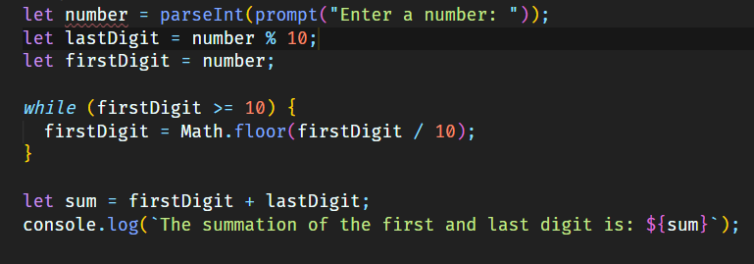Ans :

Q.28Use console.log() and escape characters to print the following pattern in JS?

1 1 1 1 1

Ans : console.log("1 1 1 1 1");

2 1 2 4 8

Ans : console.log("2 1 2 4 8 ");

3 1 3 9 27

Ans: console.log("3 1 3 9 27 ");

4 1 4 16 64

Ans: console.log("4 1 4 16 64 ");

5 1 5 25 125

Ans: console.log("5 1 5 25 125");

Q.29 Use pattern in console.log in JS?

1) 1

1 0

1 0 1

1 0 1 0

1 0 1 0 1

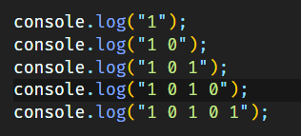Ans:

2) A

B C D

E F

G H I J

K L M N O

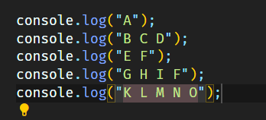Ans:

3)

1

2 3

4 5 6

7 8 9 10

11 12 13 14 15

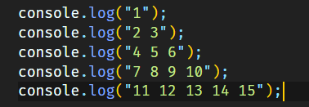Ans:

4)

*

* *

* * *

* * * *

* * * * *

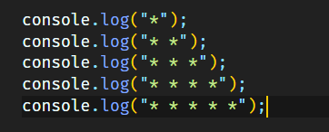Ans:

Q.30 Accept 3 numbers from user using while loop and check each numbers palindrome?

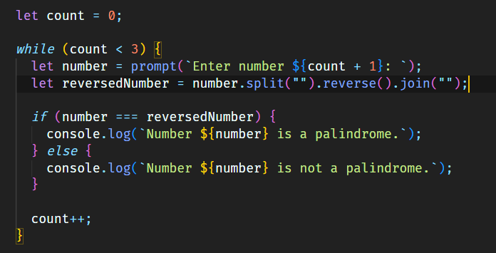Ans:

Q.31 Write a JavaScript Program to display the current day and time in the following format. Sample Output: Today is Friday. Current Time is 12 PM: 12 : 22 2 ?

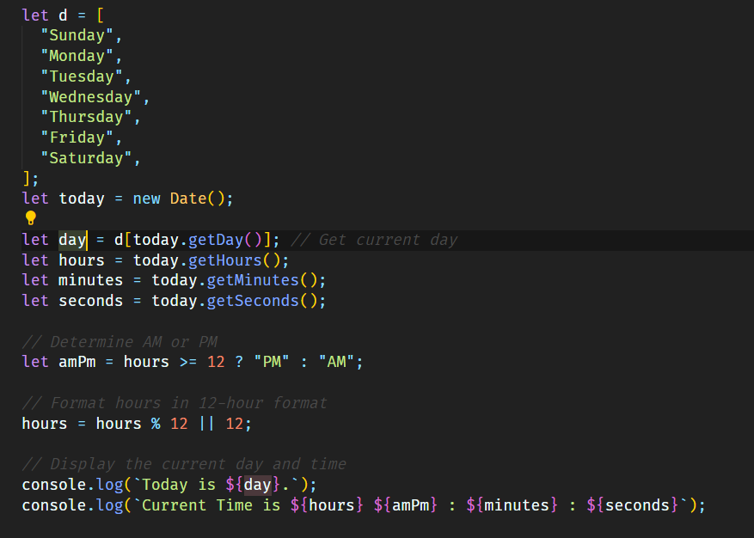Ans:

Q.32Write a JavaScript program to get the current date?

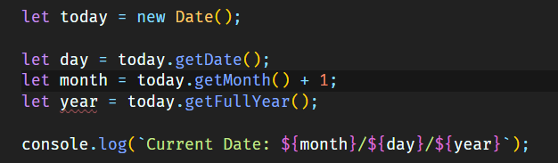Ans:

Q.33Write a JavaScript program to compare two objects?

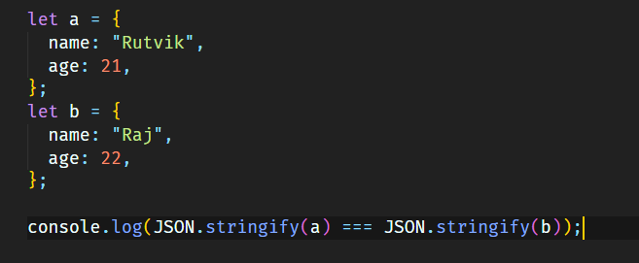Ans:

Q.34Write a JavaScript program to convert an array of objects into CSV string?

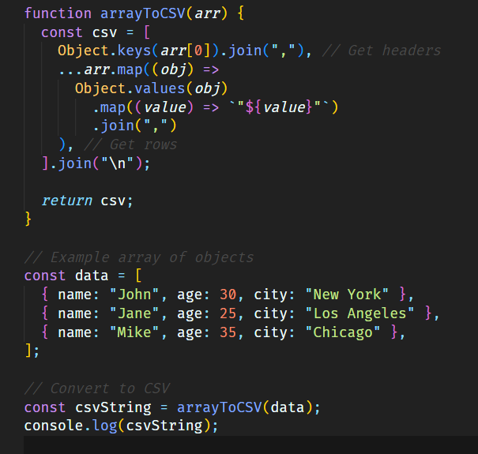Ans:

Q.35Write a JavaScript program to capitalize first letter of a string?

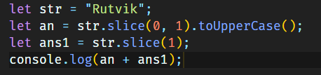Ans:

Q. 45 Write a JavaScript program to determine if a variable is array?

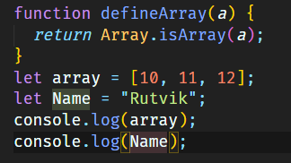Ans:

Q.46 Write a JavaScript program to clone an array?

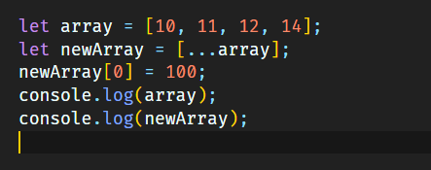Ans:

Q.47 What is the drawback of declaring methods directly in JavaScript objects?

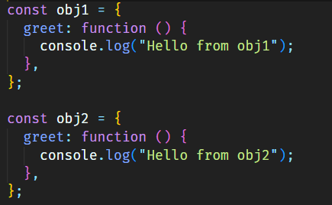Ans:

Q.48 Print the length of the string on the browser console using console.log()?

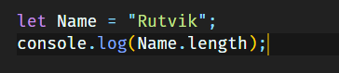Ans:

Q.49 Change all the string characters to capital letters using toUpperCase() method?

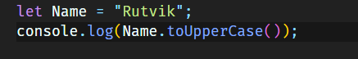Ans:

Q.50 What is the drawback of declaring methods directly in JavaScript objects

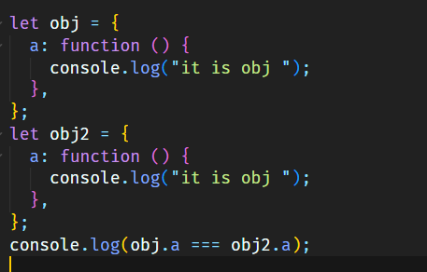Ans:

Q.51 Write a JavaScript program to get the current date. Expected Output : mm-dd-yyyy, mm/dd/yyyy or dd-mm-yyyy, dd/mm/yyyy?

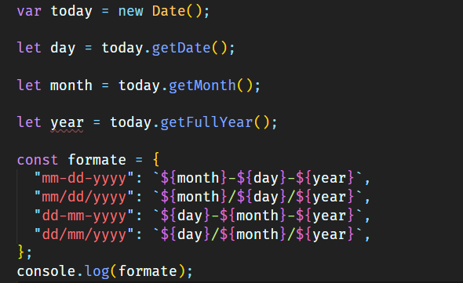Ans:

Q.52 Use indexOf to determine the position of the first occurrence of a in 30 Days Of JavaScript?

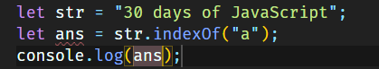Ans:

Q,53 Use lastIndexOf to determine the position of the last occurrence of a in 30 Days Of JavaScript?

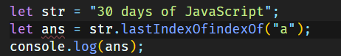Ans:

Q.54 Form Validation in JS?

Ans: **Form validation in JavaScript ensures** that user inputs meet the required conditions before submission, enhancing security and user experience. JavaScript provides various techniques for validating form data, including checking if fields are empty, verifying email formats, confirming password lengths, and validating numeric ranges.

Q.55 Form in Email, number, Password, Validation?

Ans: To validate form fields like Email, Number, and Password in JavaScript, you can check for specific criteria such as format, range, and character requirements. Here's an example of a form with these fields, using JavaScript to validate each one.

Q.56 Dynamic Form Validation in JS?

Ans: **Dynamic form validation** in JavaScript refers to validating form inputs as the user interacts with each field, rather than waiting until the form is submitted. This provides real-time feedback, improving the user experience and reducing errors.

Q.57 how many type of JS Event? How to use it ?

Ans: **<button onclick="alert('Button clicked!')">Click Me</button>**

Q.59 What is Bom vs Dom in JS?

### Ans: **BOM vs. DOM: Key Differences**

|  |  |  |
| --- | --- | --- |
| **Aspect** | **DOM (Document Object Model)** | **BOM (Browser Object Model)** |
| **Purpose** | Represents the document structure and content. | Represents the browser and its features. |
| **Interaction** | Allows manipulation of HTML and XML documents. | Allows interaction with the browser window and its properties. |
| **Key Objects** | document, element, text, etc. | window, navigator, location, history, etc. |
| **Standardization** | Standardized across all modern browsers. | Less standardized, with some variations between browsers. |
| **Focus** | Focuses on the content of the web page. | Focuses on the environment in which the web page is displayed. |

Q.60 Array vs object differance in JS?

Ans:

• **Array**: An array is an ordered collection of elements, where each element can be accessed by its numeric index. Arrays are typically used when the order of elements is important or when you need to store a list of items. example arr[12,13,14]

• **Object**: An object is a collection of key-value pairs, where each key (or property) is a string (or Symbol) that maps to a value. Objects are typically used for storing data with properties and methods.obj={ name:bansi,age:23}

Q.61 Split the string into an array using split() Method?

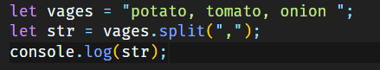Ans:

Q.62 Check if the string contains a word Script using includes() method?

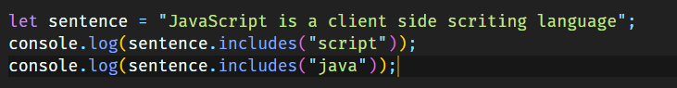Ans:

Q.63 Change all the string characters to lowercase letters using toLowerCase() Method.

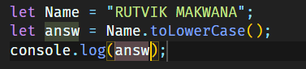Ans :

Q.64 What is Character at index 15 in ’30 Days of JavaScript’ string? Use charAt() method.

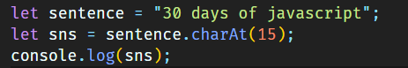Ans:

Q.65 copy to one string to another string in JS?

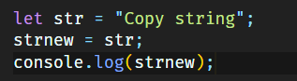Ans: